**NAME :** HARIKRISHNA N

**SRN:** PES1UG21CS217

**SEC:** D

**SUB:** DATABASE TECHNOLOGIES

**ASSIGNMENT - 1**

**(a) Database Preparation: -**

Relational schema: schema with 5 tables, with 4 relations.

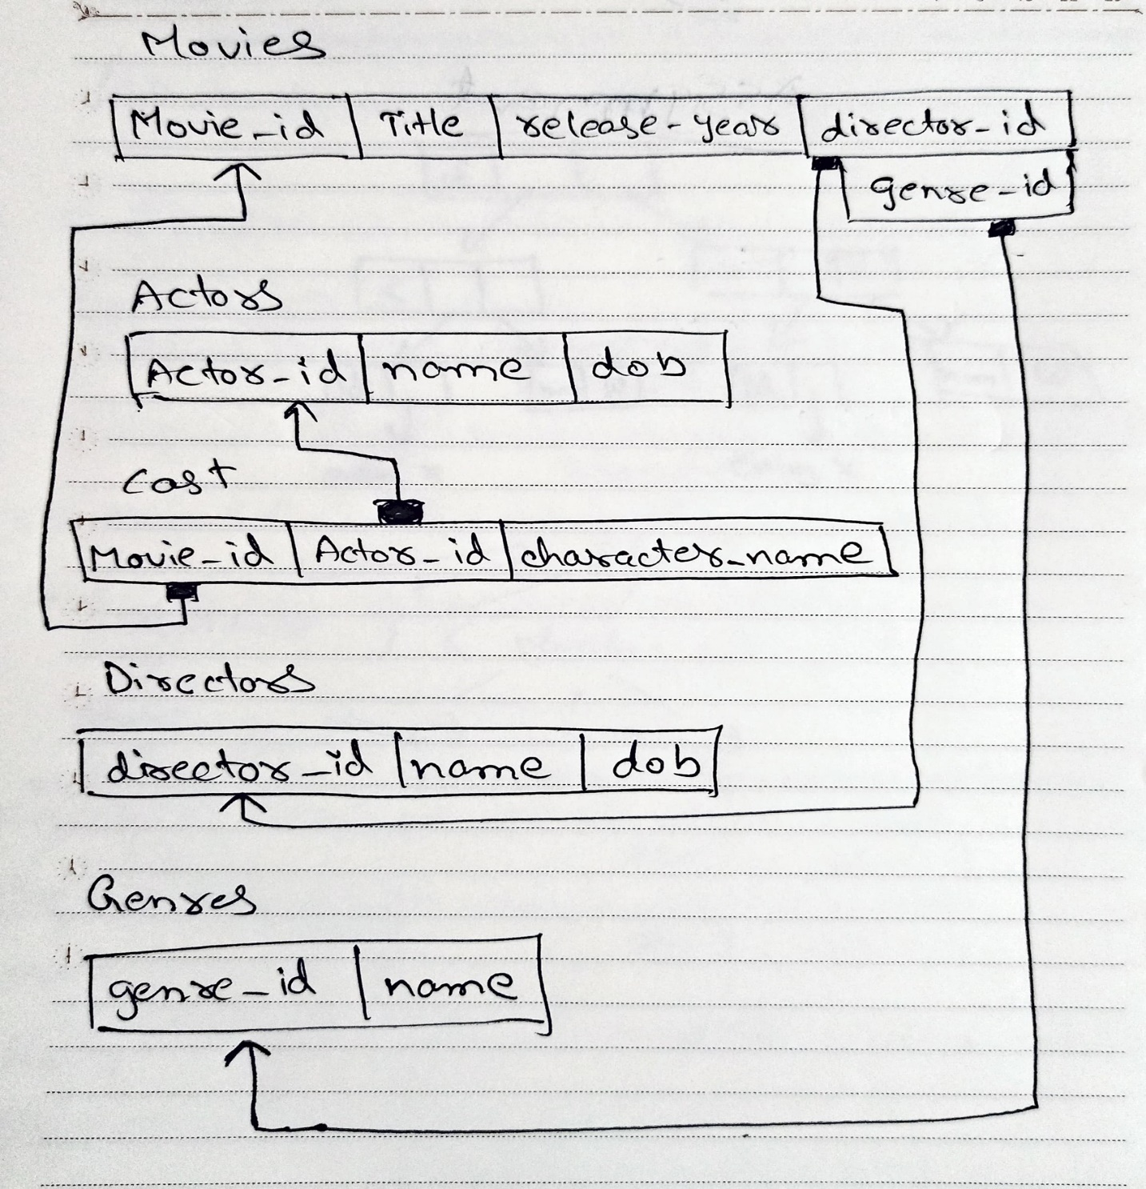

Database creation: creating the database as

‘dbt24_a1_pes1ug21cs217_Harikrishna’.

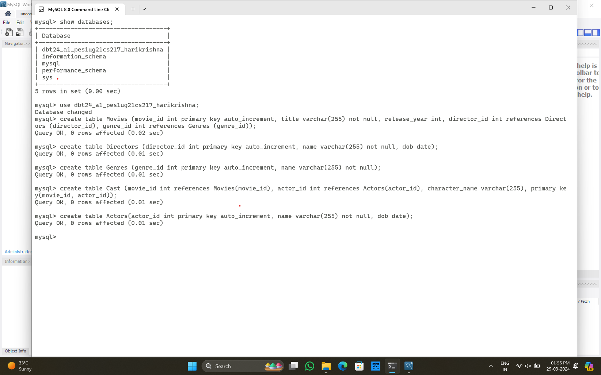

Tables creation: creating 5 tables namely movies, directors, genres, cast and actors.

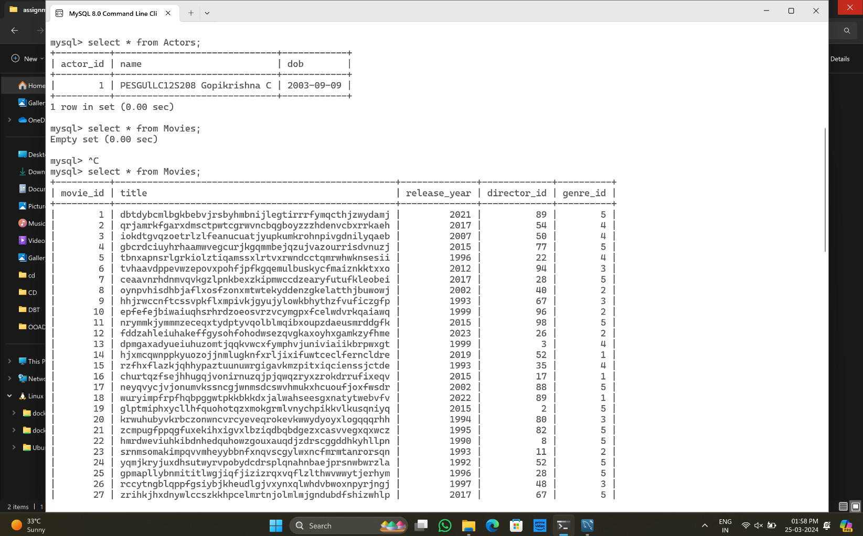

Next, populating the database with 10,000+ entries in movies and actors tables, other tables with decent number of rows using **code.py** program, which generates random strings, dob, years, values and put it in the tables, where first the directors table is filled with 100 rows, then 5 genres are added to genres table, then 10000 actors filled in actors table, then 10000 movies to moves table, then based on the 4 tables data the cast table is filled where it reached to 19,974.

(b) Queries Creation and Performance Measurement: -

Execute "SELECT *" queries on all tables to display data and count the rows:

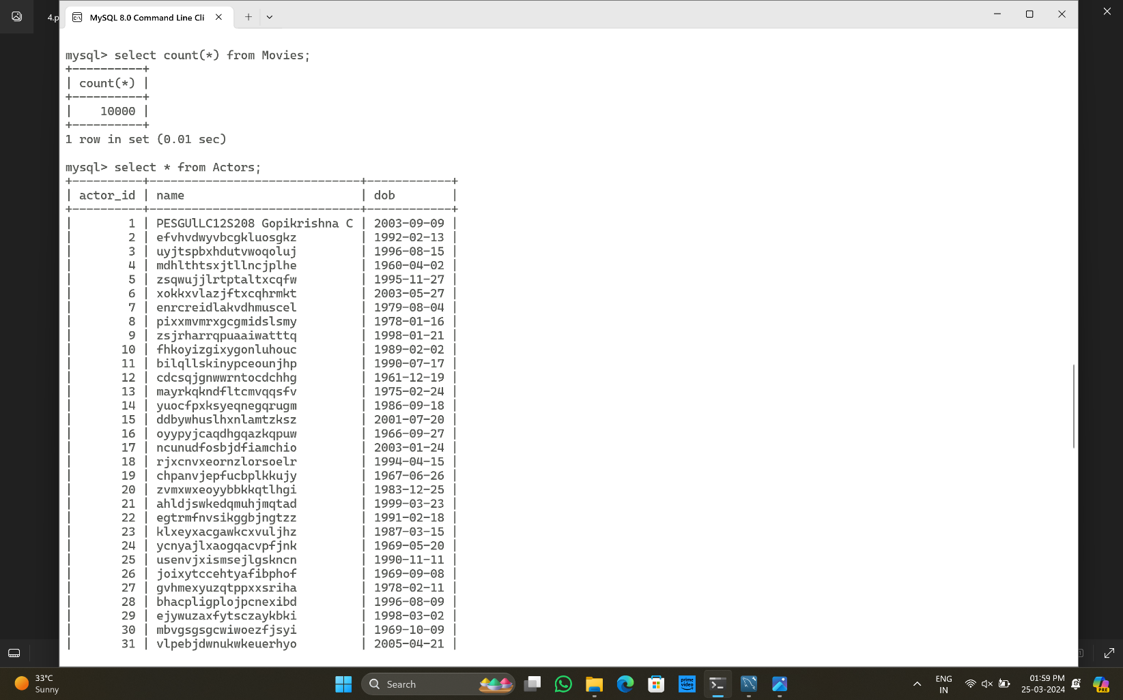

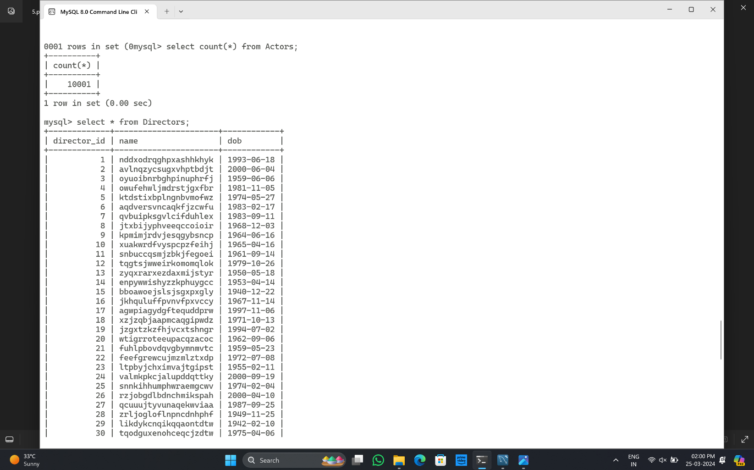

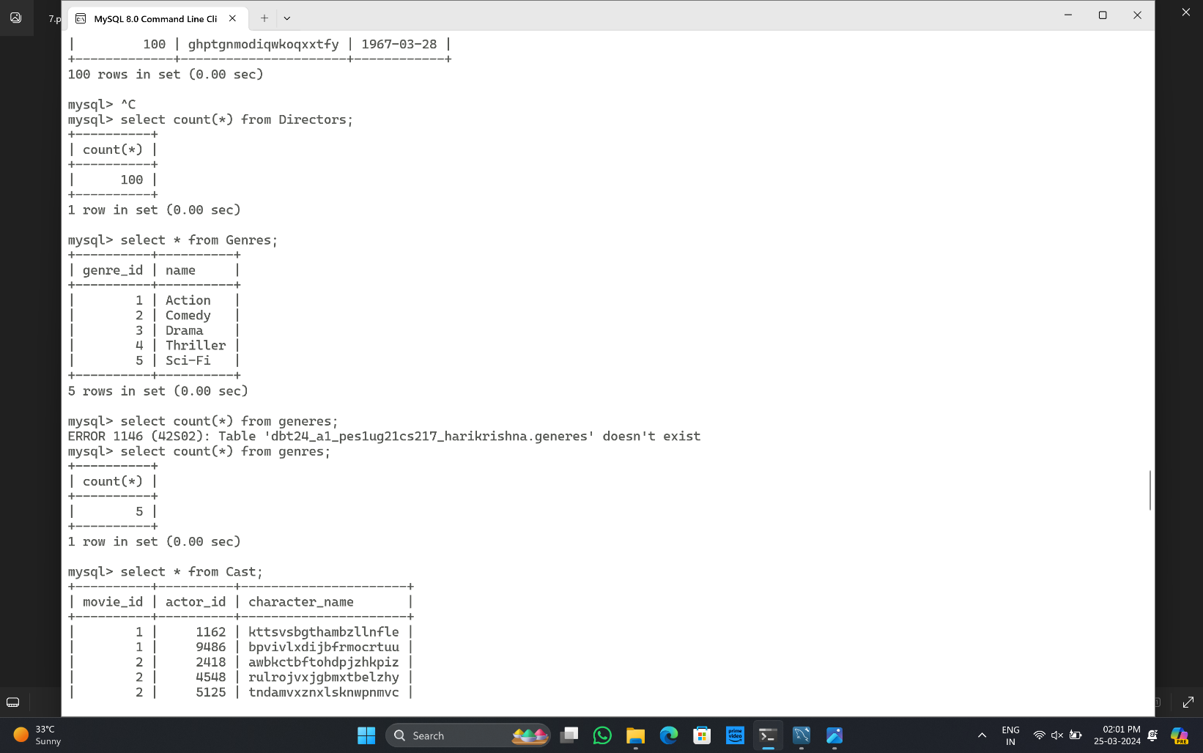

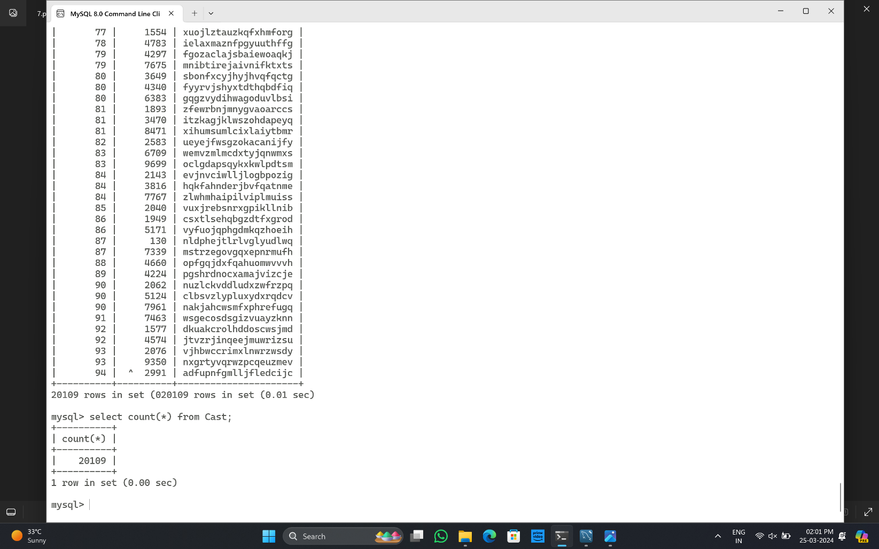

Index scan example 1 using ix_mov_gen for faster query processing:

It took 0.01 sec for execution

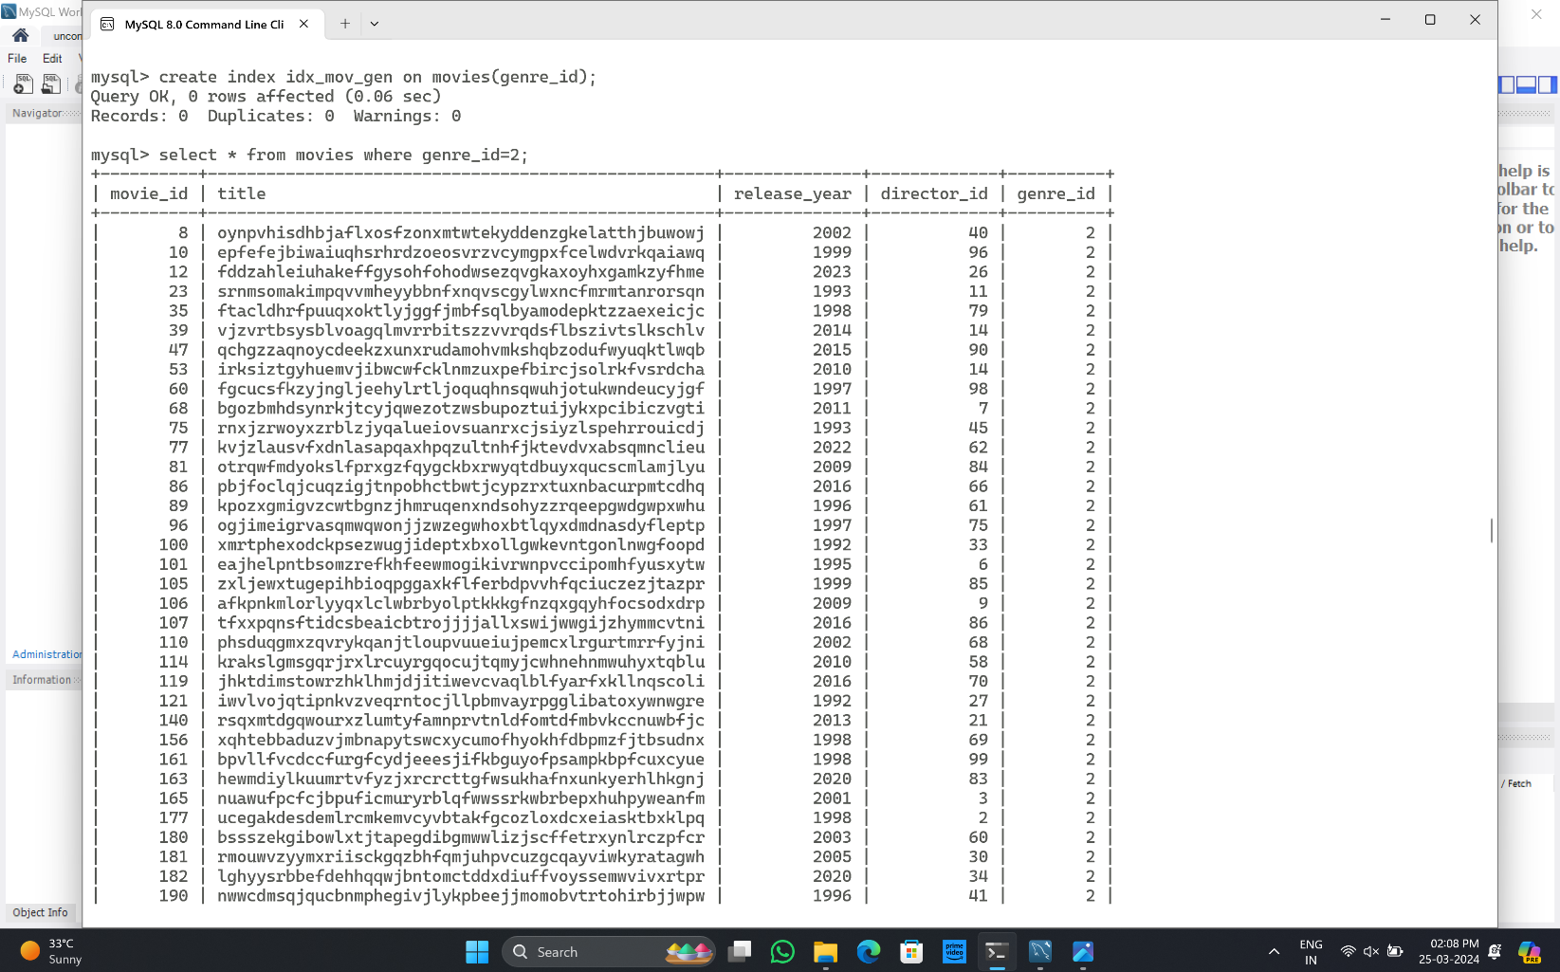

Index scan example 2 using ix_mov_year for faster query processing:

It took 0.00 sec for execution

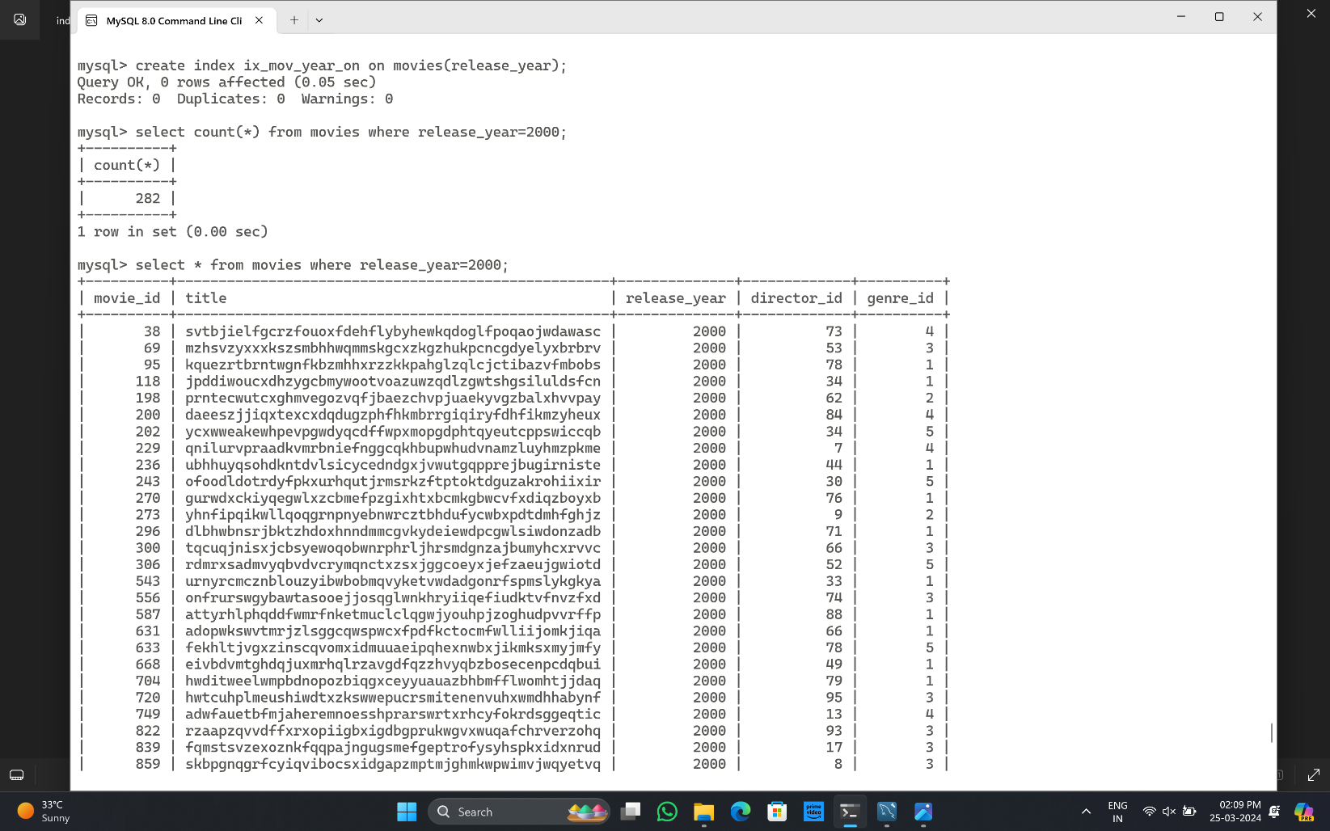

Table scan example 1:

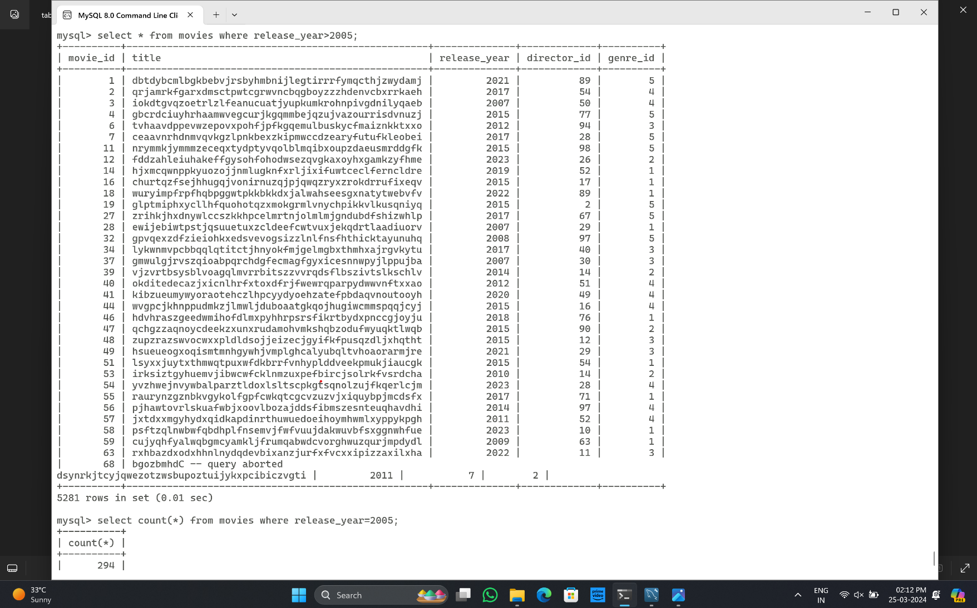

Table scan example 2:

It took 0.00 sec for execution

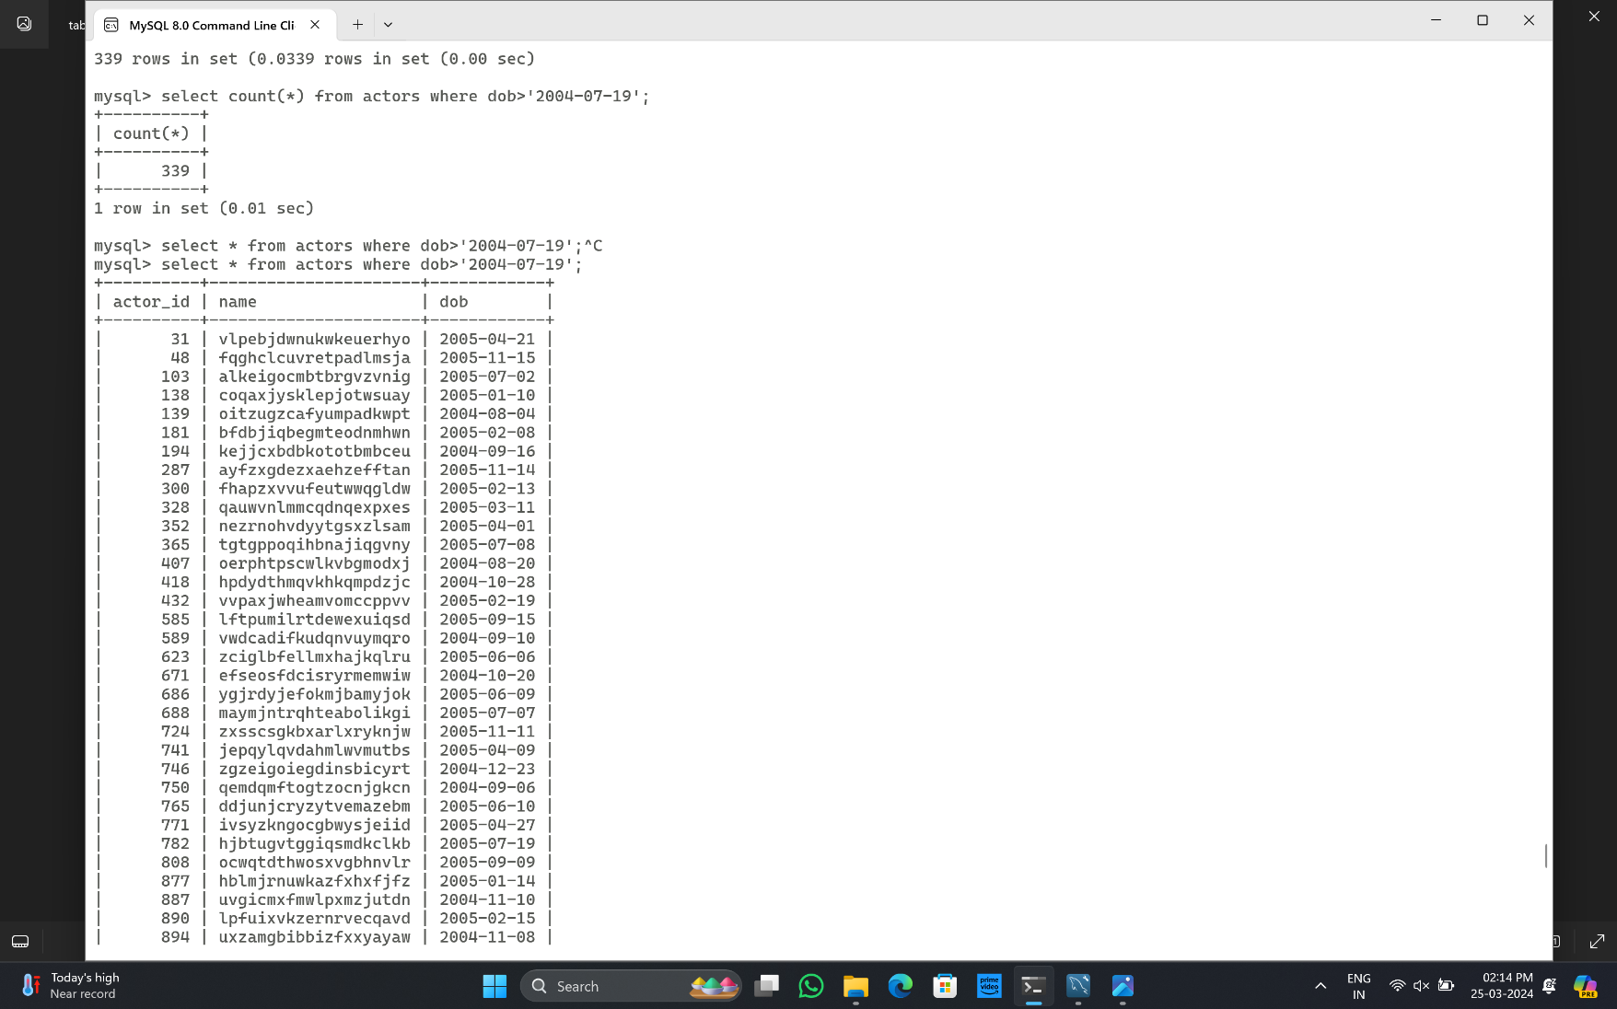

Multi-table joins involving 3 tables -

Using "SELECT *" query with a subset of columns:

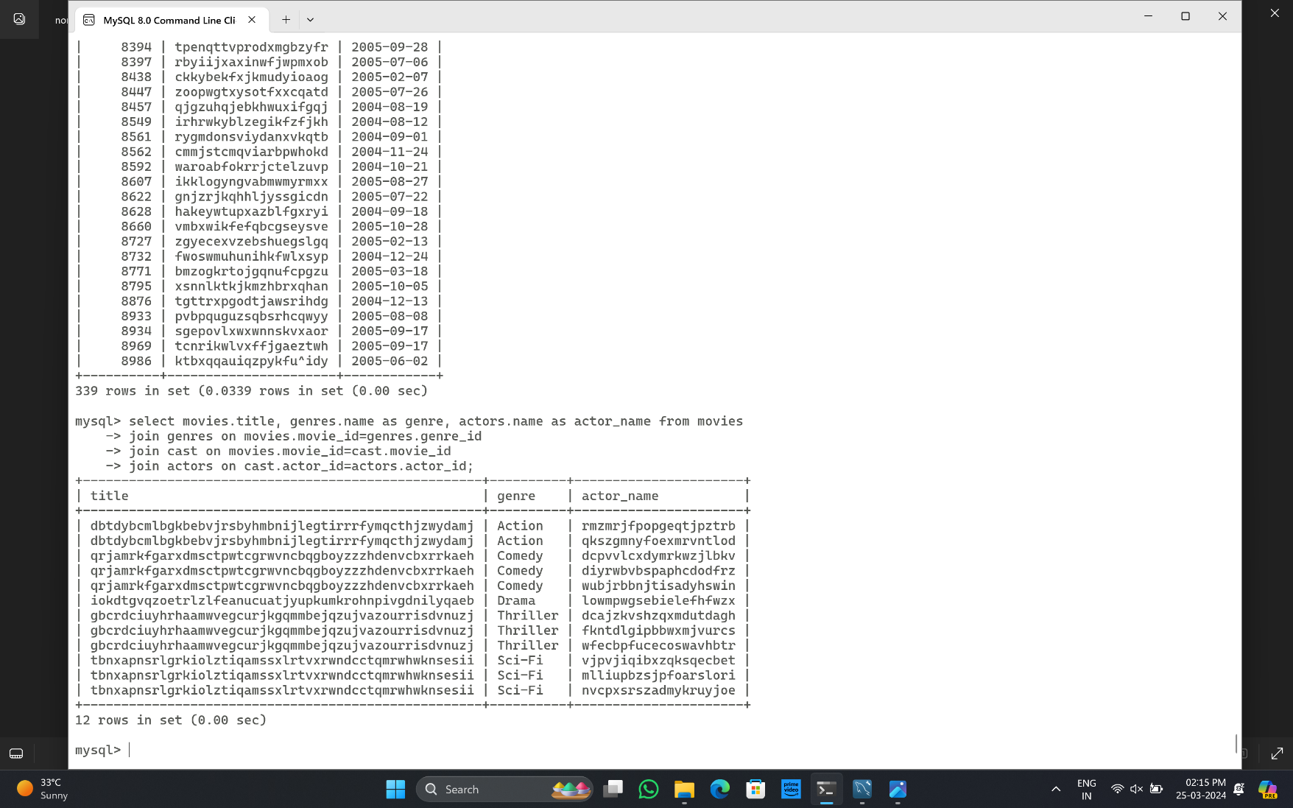

Using conditional "SELECT" query with a subset of columns:

It took 0.03 sec for execution

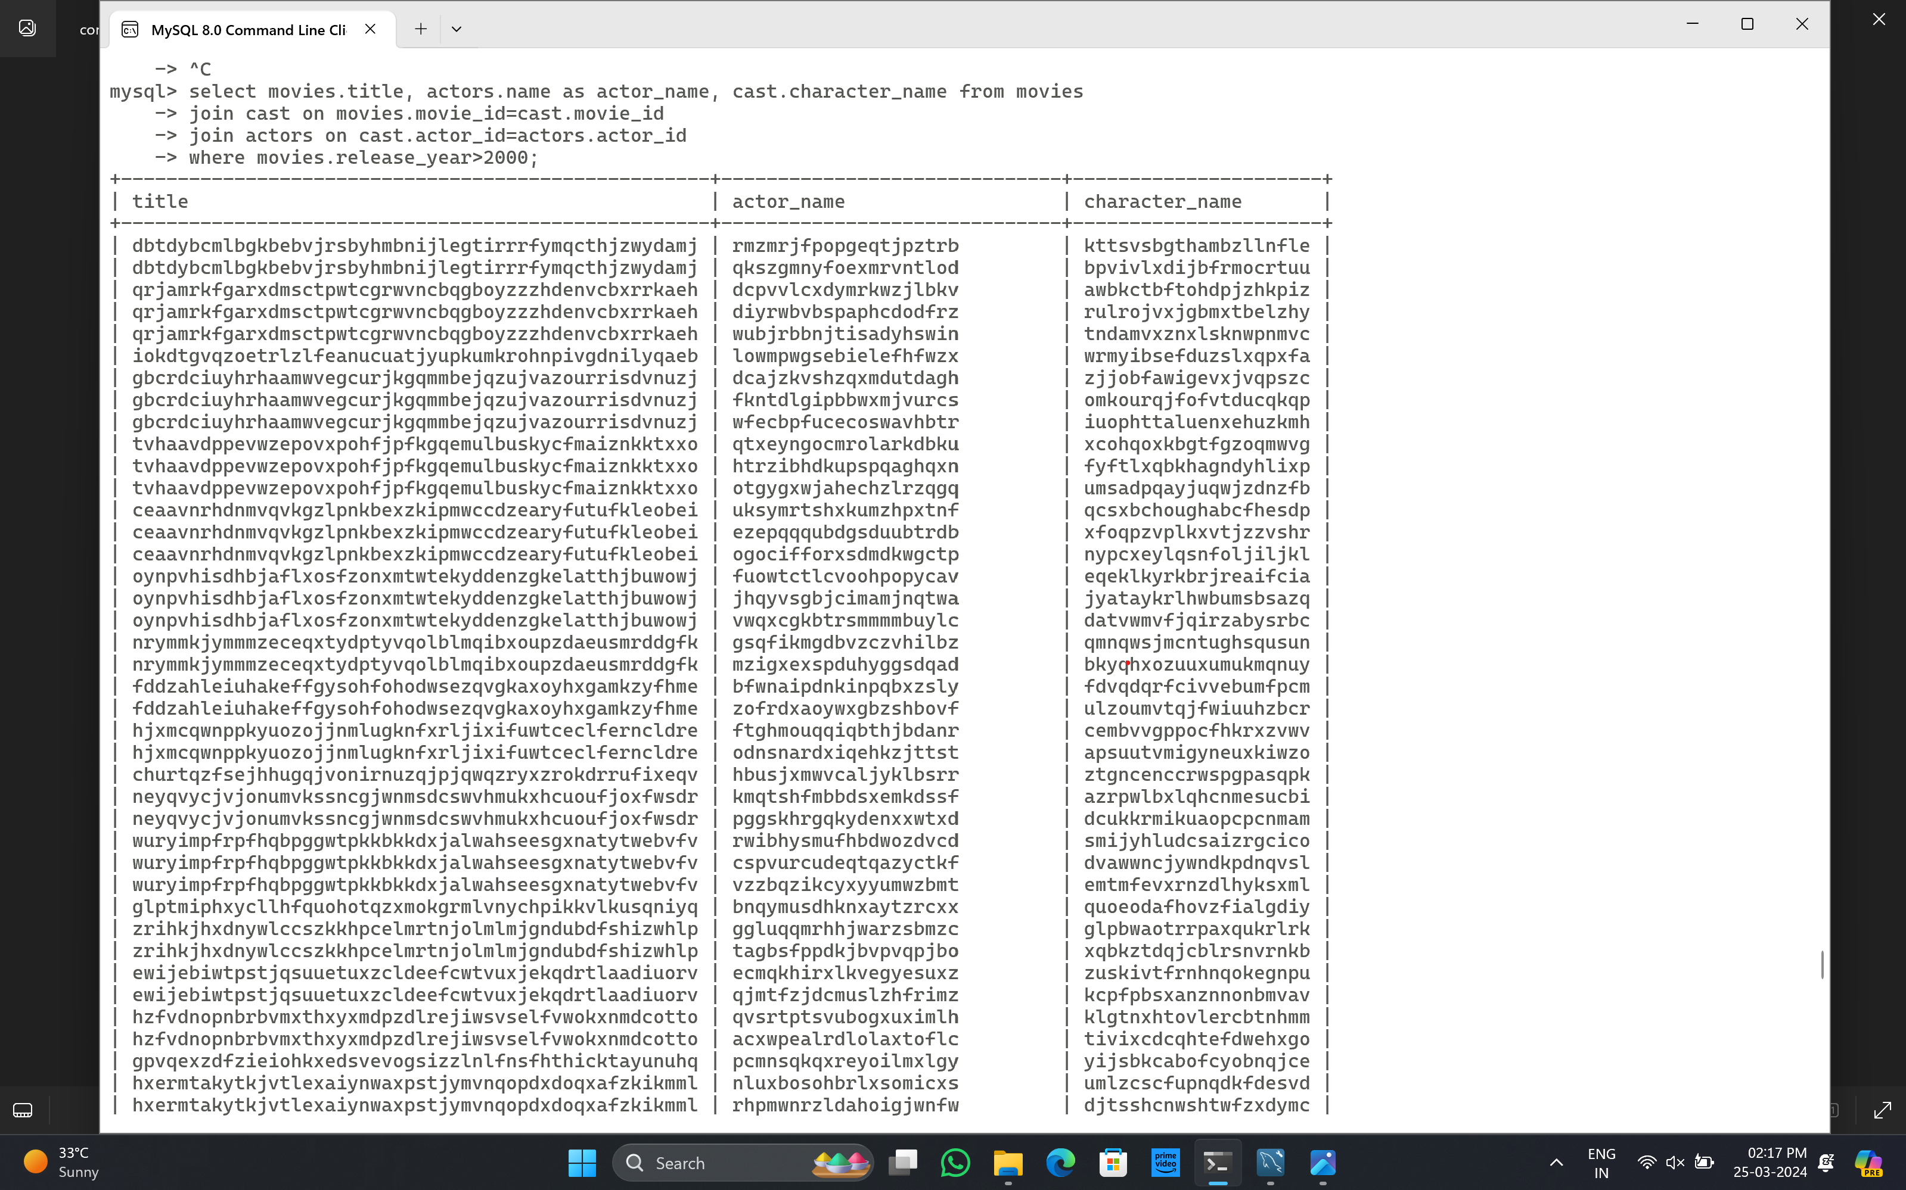

# (c) Indexing for Query Performance Improvement: -

Before indexing sample three table join: as you can see before the indexing the run time is 0.09 secs.

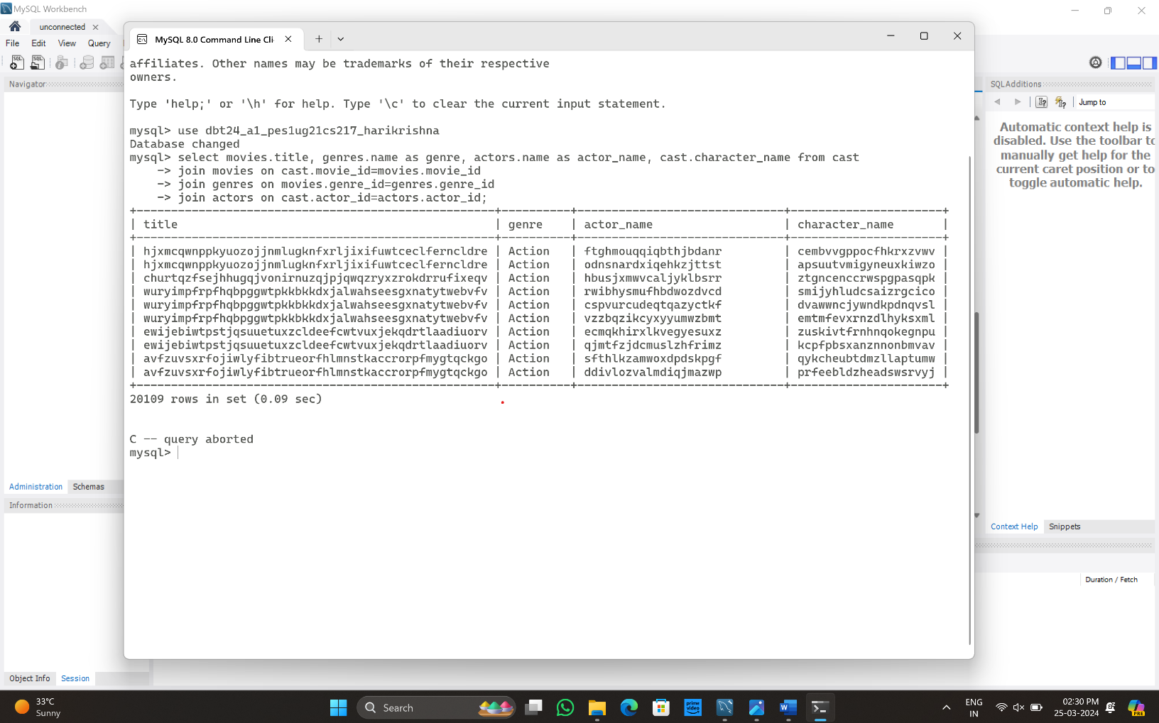

Indexing some tables:

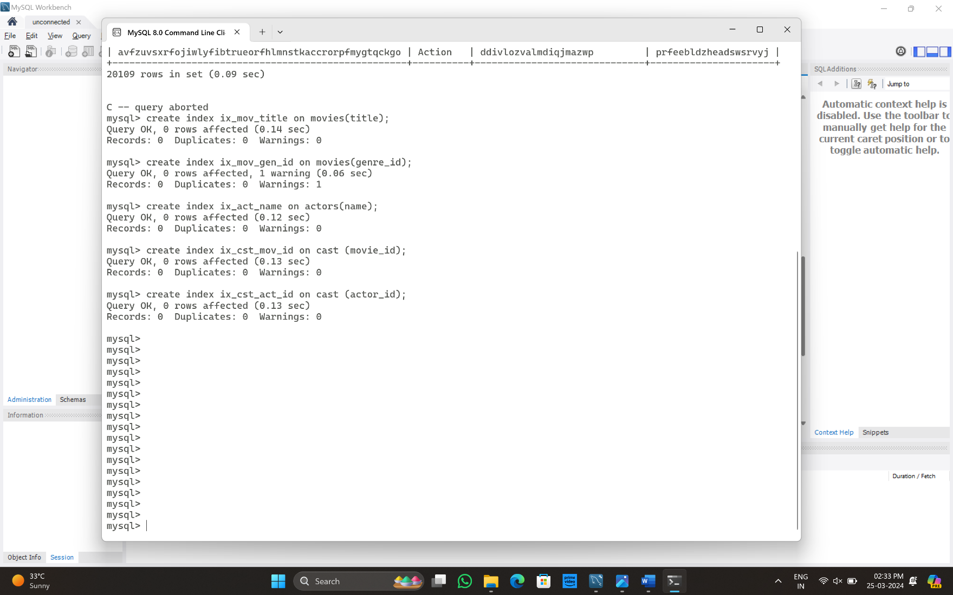

After indexing sample three table join: as you can see the execution time decreased to 0.07 secs, After indexing sample three table join with (Explain):

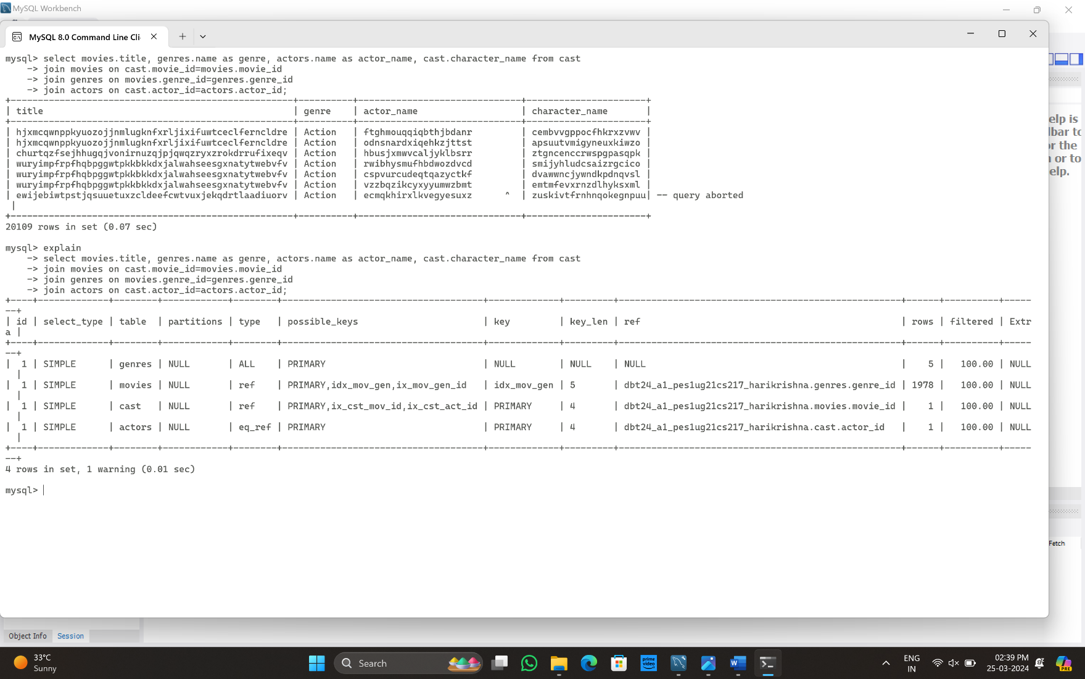

# (d) Query Optimization with Varied Join Orders and Types: -

Altering the join order of tables in multi-table join query example 1

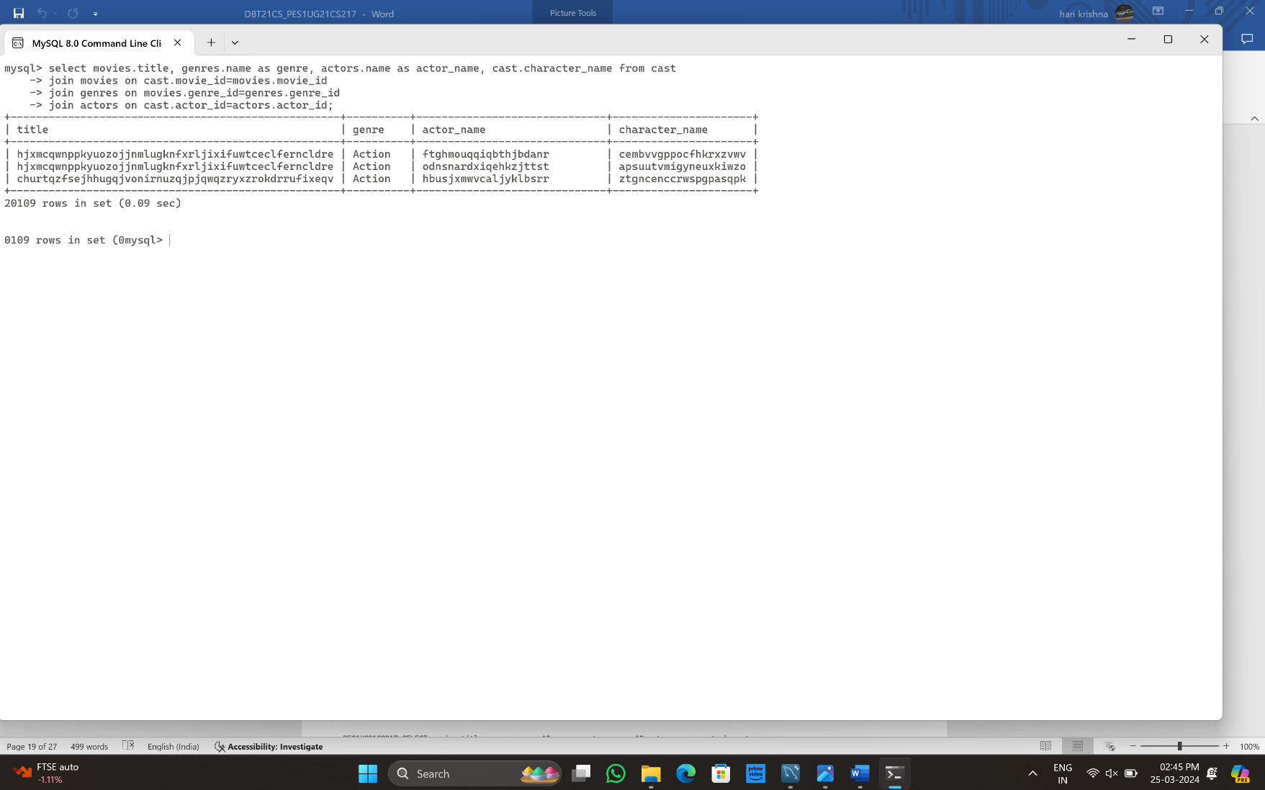

Altering the join order of tables in multi-table join query example 2:

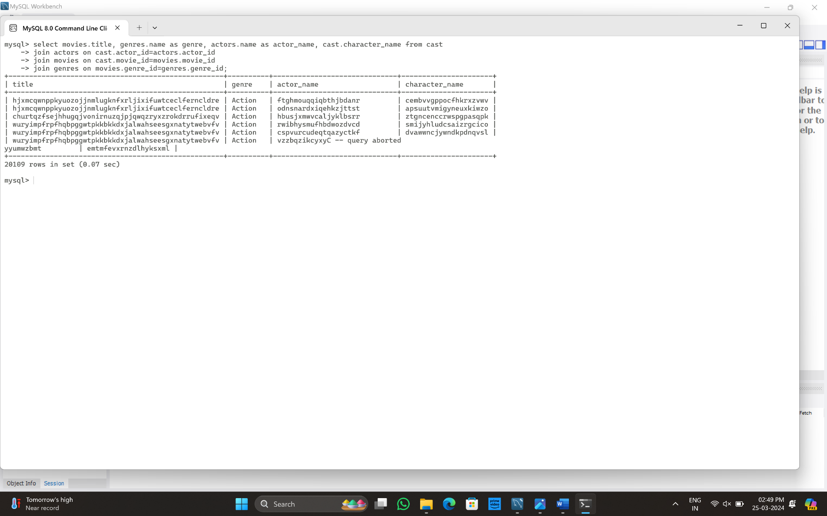

Incorporate a variety of join types such as left joins:

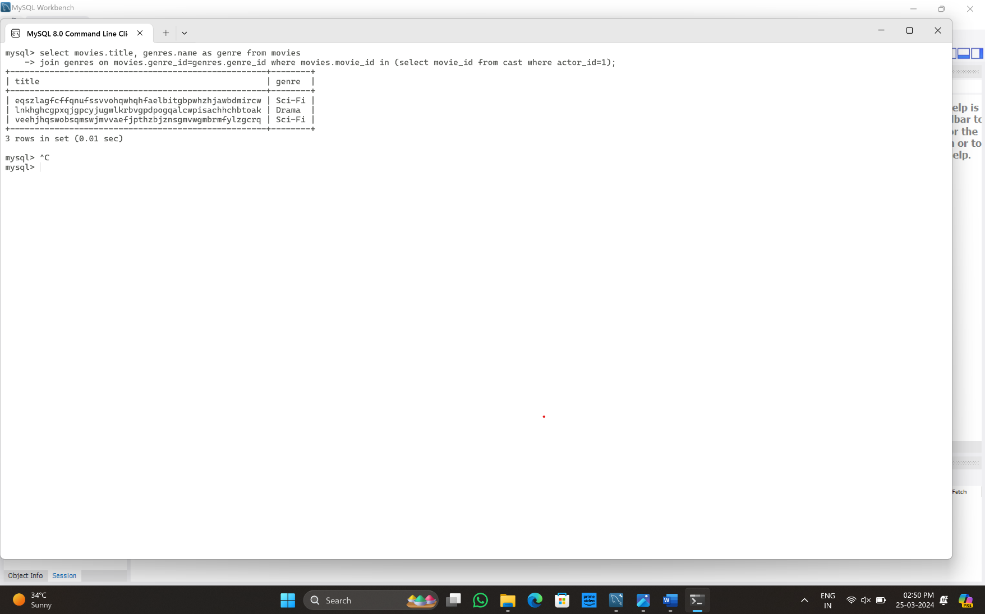

Incorporate a variety subquery:

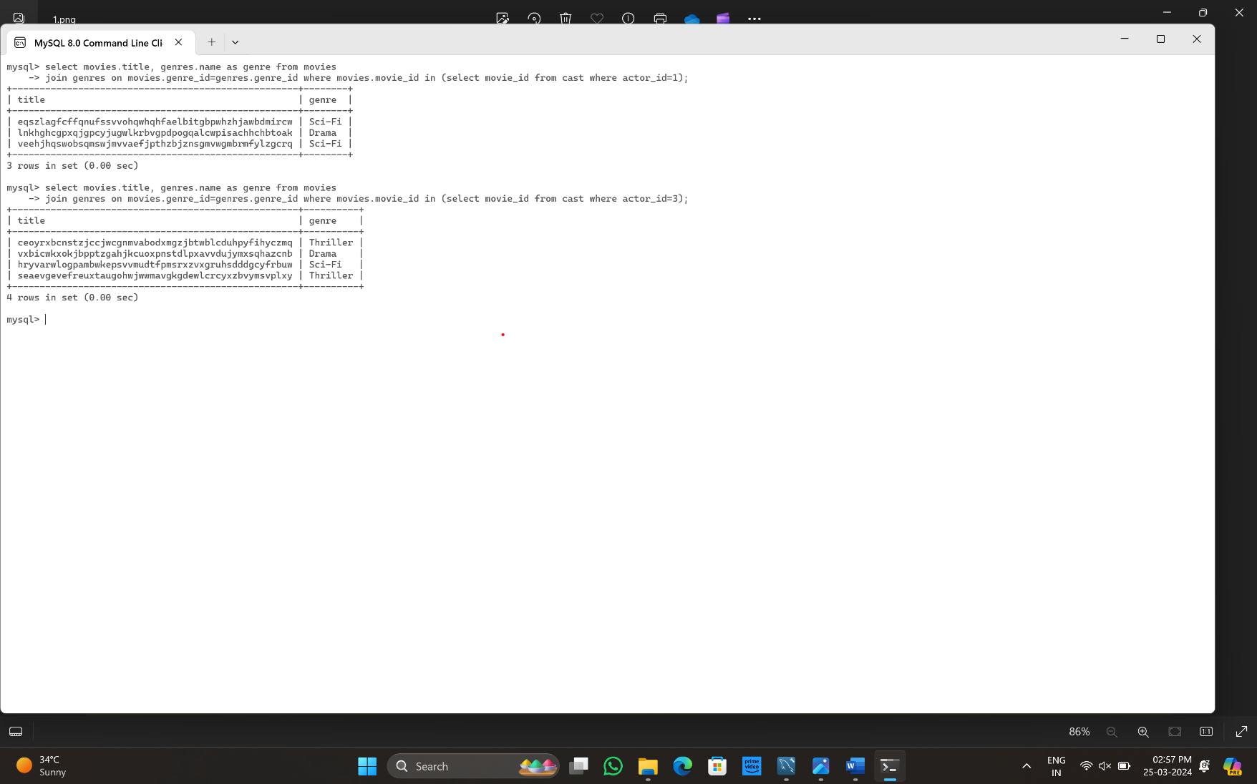

# (e) Query Analysis and Optimization: -

**Part 1: Query Analysis:**

Complex three table join query:

>> select movies.title, actors.name as actor_name from movies join cast on movies.movie_id=cast.movie_id join actors on cast.actor_id=actors.actor_id where movies.release_year>2000;

The query is to extract movie title, actors name from joins of movies, cast and actors tables and filter them by 2000 year.

Parse tree for the complex query:

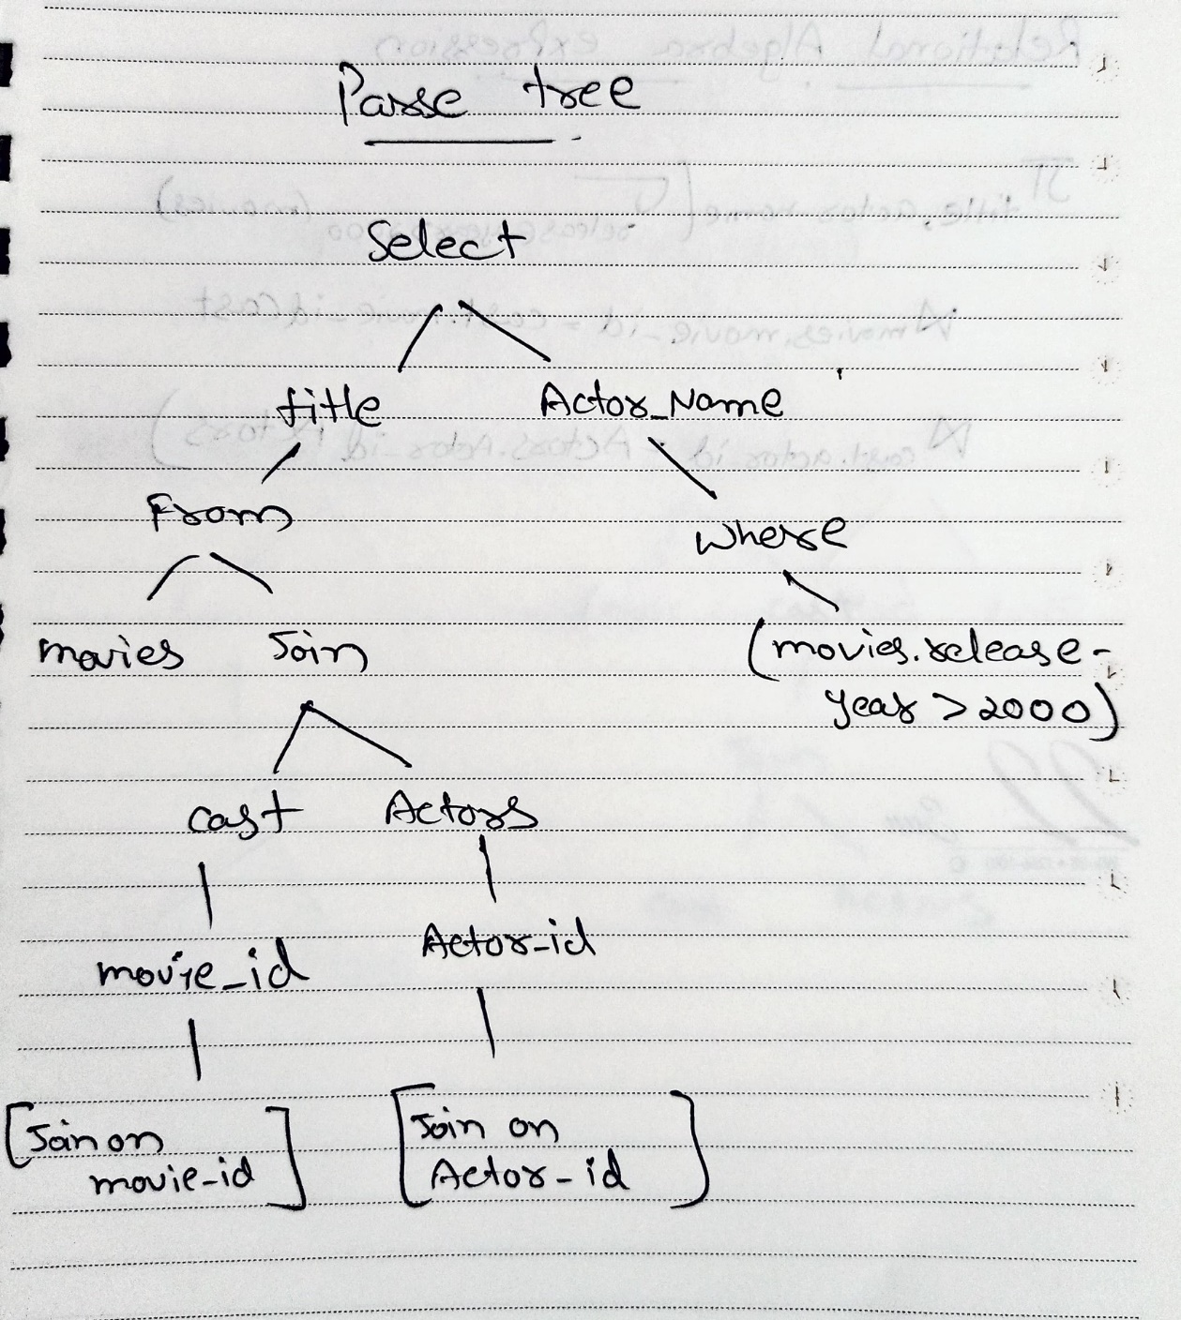

Relational algebra expression for the query:

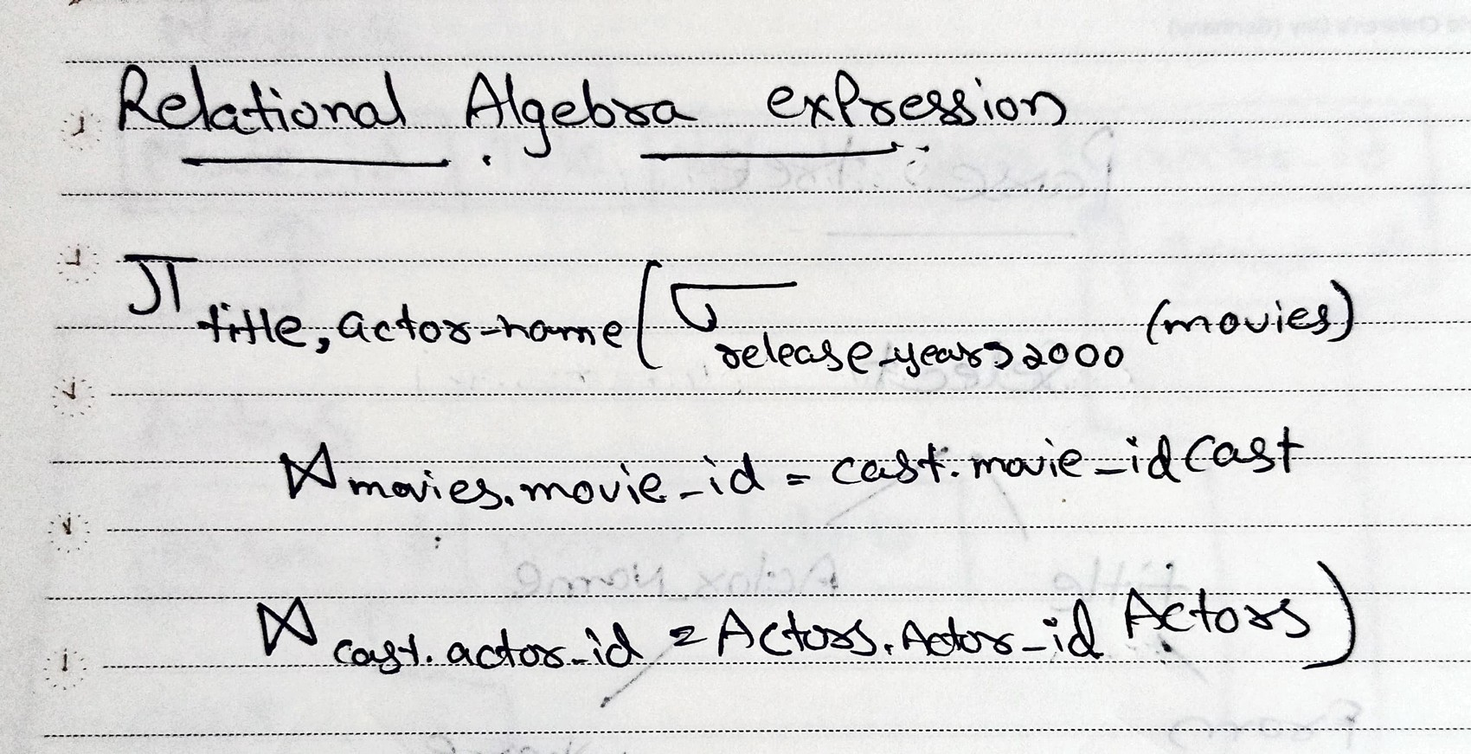

Initial query tree based on the relational algebra expression:

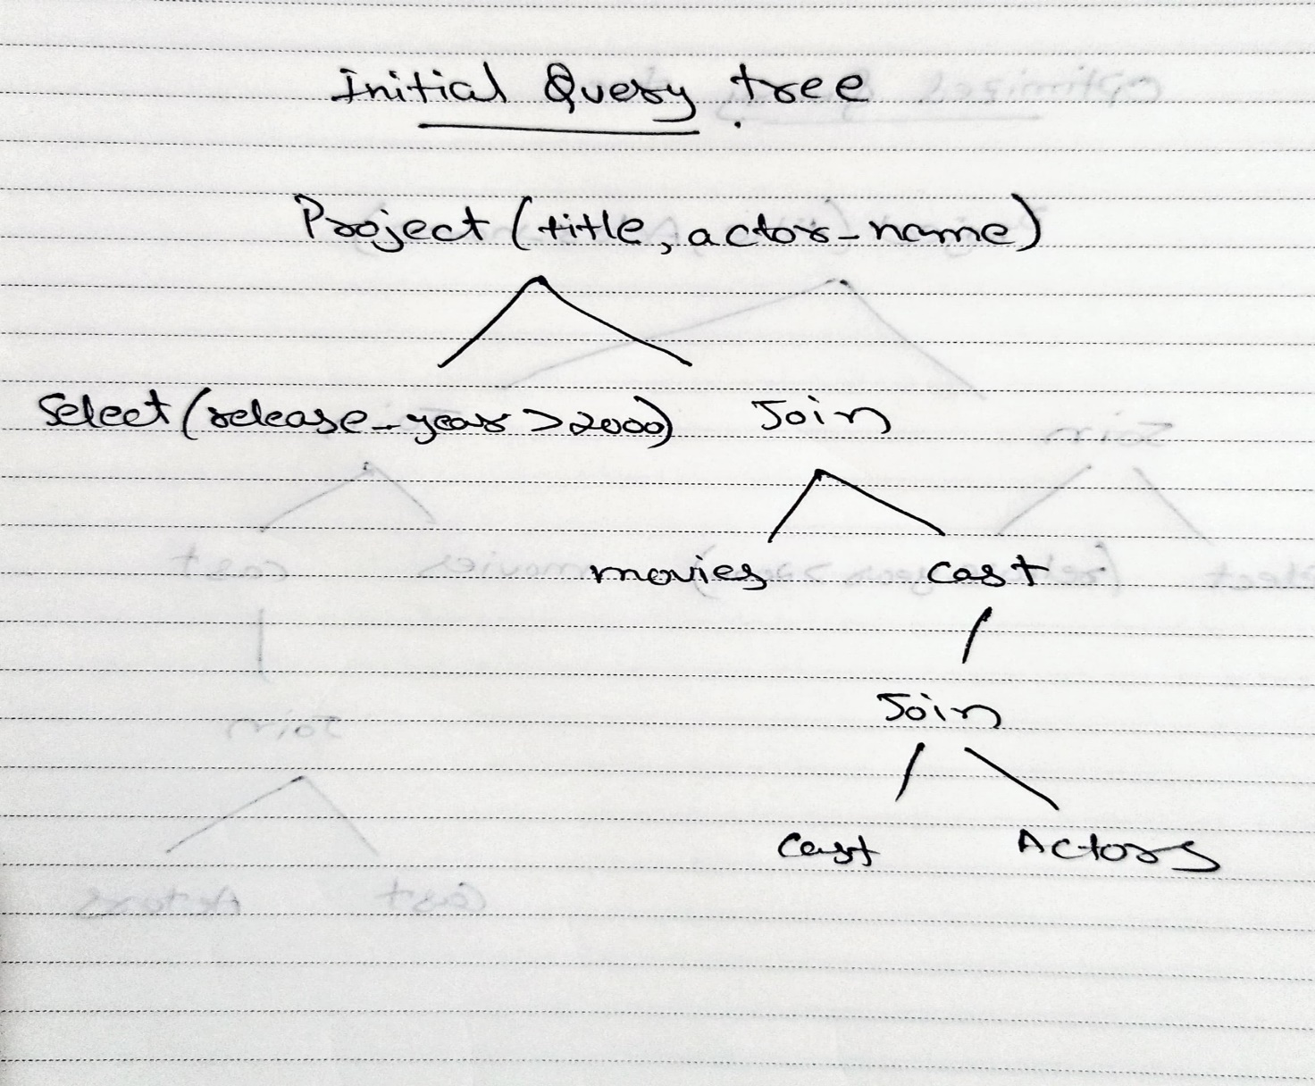

**Part 2: Query Optimization:**

Optimizing the initial query tree to enhance query performance:

Push down selection (predicate pushing):

Move the selection on release_year down to the Movies table before joining. This reduces the number of rows processed in subsequent joins.

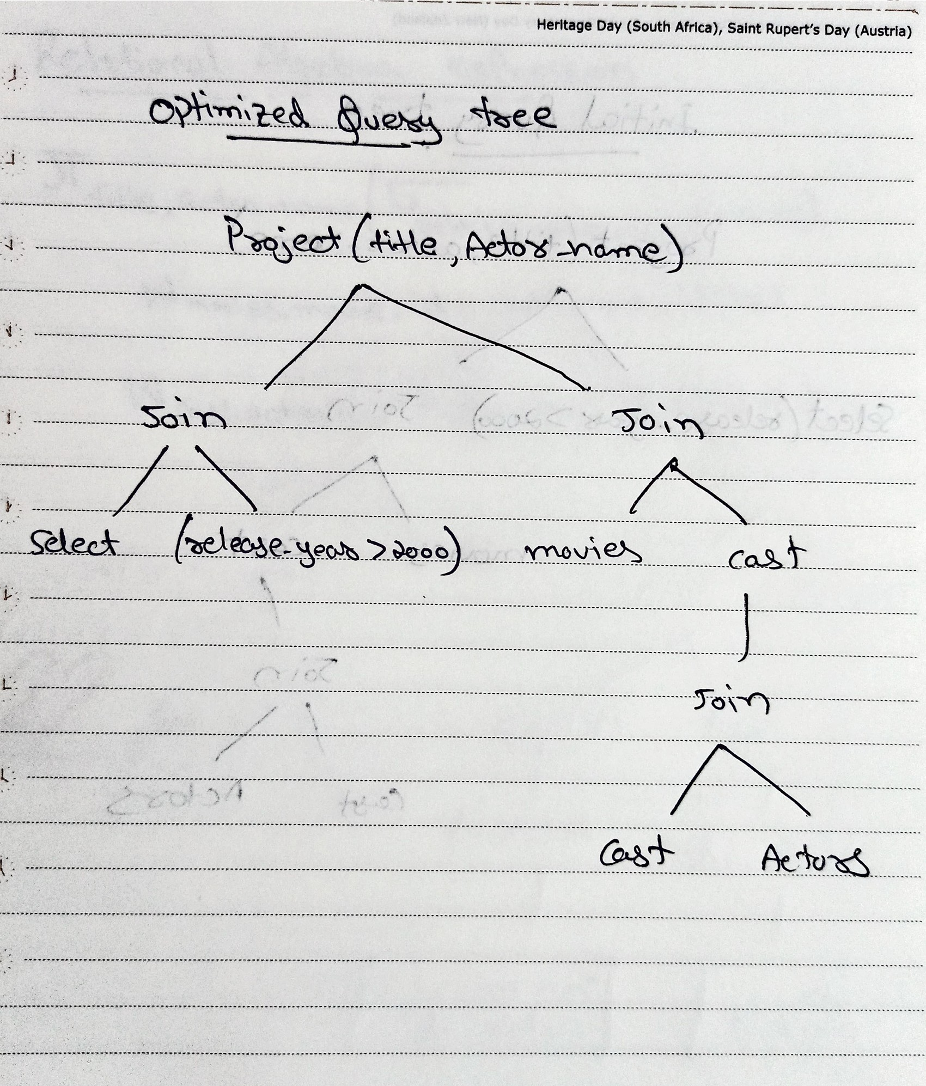

By pushing down the selection, the database filters movies based on the release year before joining them with the Cast and Actors tables. This can significantly improve performance, especially for large datasets.